MODIFIED EULER METHOD:
INTRODUCTION:
In the improved Euler method, we averaged the slopes, whereas in modified Euler method, we will average the points.
Let P₀(x₀,y₀) be the point on the solution curve.
Let P₀A be the tangent at (x₀,y₀) to the curve. Now let this tangent meet the ordinate at
x = 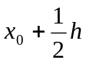at N₁.
y-coordinate of N₁= 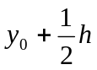 f(x₀,y₀) -----------(1)
Calculate the slope at N₁ i.e., 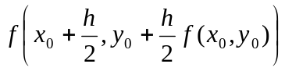
In general,
y_{n+1} = y_{n} + h 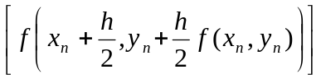 ……….(2)
Equation (2) is called modified Euler’s formula.
PROBLEMS:
- Using Modified Euler method, find y(0.2) , y(0.1) given y’ = x²+y², y(0) =1.
Sol:
Here, h = 0.1, f(x,y) = x²+y², x₀= 0, y₀ = 1, x₁= 0.1, x₂ = 0.2,
By Modified Euler method,
y₁=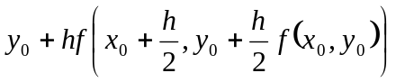 …………….(1)
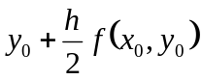= 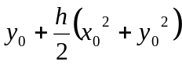 = 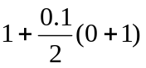= 1.05
Using in (1),
y₁=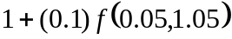
y(0.1) = 1+(0.1)[(0.05)²+(1.05)²]
= 1.1105
y₂=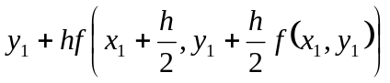
f(x₁,y₁) = f(0.1 , 1.1105) = (0.1)²+(1.1105)² = 1.24321
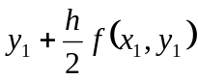= 1.1105+(0.05)(1.24321) = 1.172660
y₂ = 1.1105+(0.1)[f(0.15,1.172660]
= 1.1105+(0.1) [(0.15)²+(1.17266)²]
y(0.2) = 1.25026.
- Compute y at x = 0.25 by Modified Euler method given y’ = 2xy, y(0) = 1.
Sol:
Here, f(x,y) = 2xy, x₀ = 0, y₀ = 1, h = 0.25, x₁ = 0.25
By Modified Euler method,
y_{n+1}=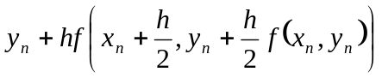 ………(1)
y₁= ………(2)
f(x₀,y₀) = f(0,1) = 2(0)(1) = 0
y₁ = 1+(0.25)[f(0.125,1)]
= 1+(0.25) [2x0.125x1]
y(0.25) = 1.0625.

